Chapter-2: How to install Python

And its Navigator (Anaconda)

Downloading Python

* To install python, go to your Web Browser; and visit [*www.python.org*](http://www.python.org)*.*
* There you will see many tabs-

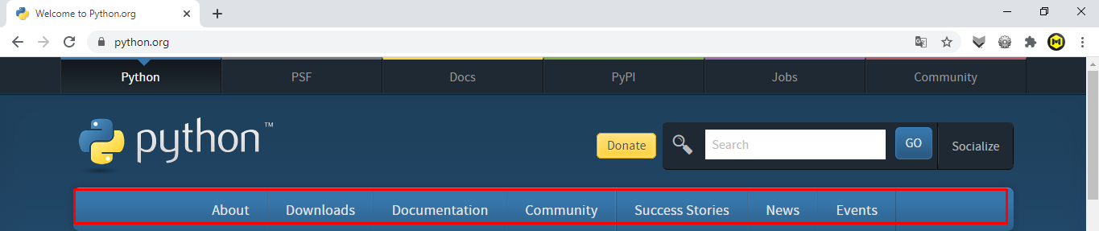

* Go to *Downloads tab(www.python.org/downloads/)* and there you will see:

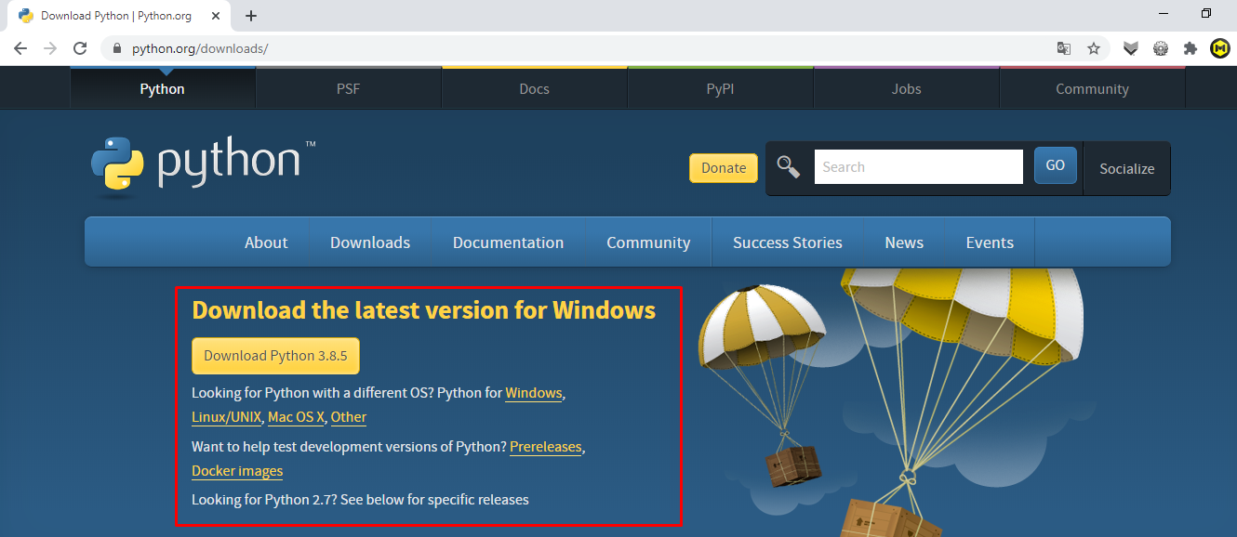

* Click on **Download Python 3.8.5**.
* It will be downloaded.
* A ready IDE or coding environment will come named as (IDLE (Python 3.8 32-bit).

Downloading its Navigator

* Open your Web Browser and visit *www.anaconda.com/products/individual*
* There you will see-*.*

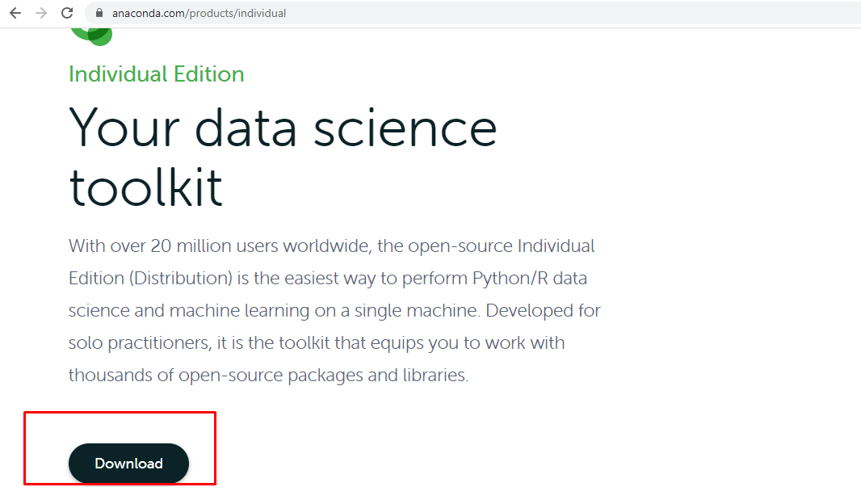

* Click on download and afterwards, this screen will appear:

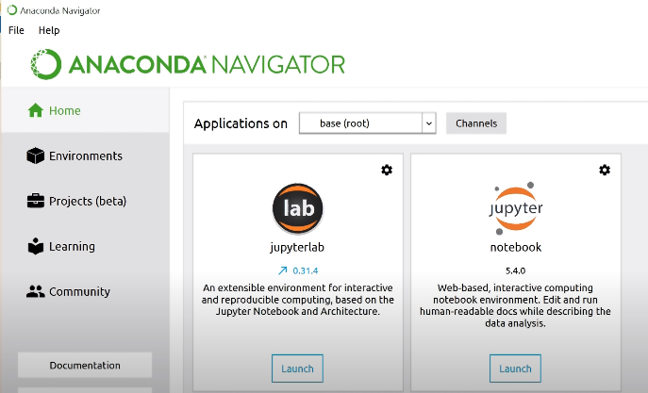

* Go to Jupyter Notebook and many tabs will appear click on any tab. In the screen a button will come named as *New.* After clicking at it; a drop-down menu will come.
* Click on the button just under *Notebooks.*
* If you want to rename; go to *File tab* and after it click on rename.
* To open the same file, again launch Jupyter Notebook and in the same tab you have saved the notebook and the file will appear as *thename*.*ipynb*.